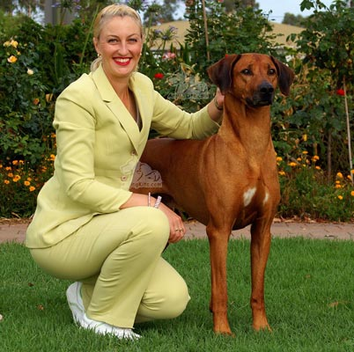
Cheryl Currie-Thompson (Mrs)
INTERNATIONAL ALL BREEDS JUDGE
Caprivi Kennels, Australia

Having grown up with various breeds of dogs such as Cocker Spaniels, Boxers, Dobermans & German Shepherds; my first experience in competition was with a German Shepherd in the Obedience arena. My first conformational show dog was a Rhodesian Ridgeback, 20 years ago. This dog went onto become a multiple Best in Show winner and firmly established my desire to continue with this satisfying hobby.

Over the last 20 years, I have included Salukis, Whippets and Bluetick Coonhounds in my home, however, my main love will always be the Rhodesian Ridgeback and we currently have 7 at home. I have had the pleasure to handle various other breeds to their Championship titles including Bloodhounds and Shetland Sheepdogs. I have handled many breeds over the years in all groups.

We have been honored to have bred and/or owned 23 Champions including 5 Grand Champions. Caprivi Rhodesian Ridgebacks have won Multiple Best in Show awards, both at All Breeds and Specialty level. Both puppies and frozen semen have been imported and exported to various countries including South Africa, USA, Japan, Singapore. We are proud to have owned and bred the No. 1 Rhodesian Ridgeback in Australia for the year 2003, 2004, 2005, No. 2 in 2006 & No. 1 in 2008. We had No 1 Rhodesian Ridgeback bitch in 2009 (also No 1 bitch in 2007) and currently in 2010.

I have also successfully competed with Rhodesian Ridgebacks in the Agility and Obedience fields and many of our dogs have Endurance Test titles to their names.

I have also presented numerous lectures on various hound breeds to trainee hound judges for educational purposes. I have held executive positions on various canine based committees over the years.

In the last few years I have had the chance to travel to many countries like South Africa, USA, India and Mexico, to attend large dog exhibitions and have been fortunate to include kennels visits. I have judged in both Finland and Brazil and in most states of Australia.

I thank you for the opportunity to introduce myself.

www.caprivi.com.au

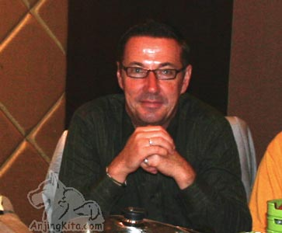
ERIC SOTI
Australia

Eric has been involved in showing and breeding dogs for some 30 years. He has judged extensively, throughout Australia, New Zealand, Japan, Philippines, India, Indonesia, Thailand and the United States of America. His involvement has included Standard Long Haired, Standard Smooth Haired, Miniature Long Haired and Miniature Smooth Haired Dachshunds, Basset Hounds, English Springer Spaniels and more recently Pugs.

Eric is an All Breeds Judge.

For many years I have concentrated on the breeding and exhibiting of Standard Long-Haired Dachshunds, in partnership with Wolfgang Schnitzer, under the “Keaton” prefix. With this variety we have been successful in breeding Royal Challenge winners in most States of Australia. We have also been successful in the Specialty ring, with Best in Show winners, which were either bred or owned by us. This has included winning Best Exhibit In Show and Runner-up in Show at five of the nine National Specialties held. We have bred the only two Grand Champion Longhaired Dachshunds in New Zealand. We also have a dog in Singapore that is a Grand Champion. We are the only Longhaired Dachshund breeders to have bred a dual Australian and New Zealand Grand Champion.

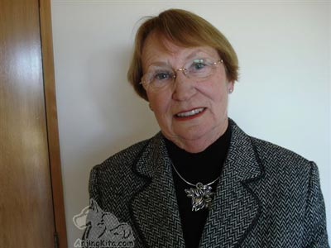
Shona E Prebble
New Zealand

Pedigree dogs over a lifetime have led me to my present activities within the canine world.
The influence of Pembroke Welsh Corgis in the latter years of childhood and my love od all dogs contributed greatly to the establishment in 1960 of our own “Melandar Kennels” in partnership with my husband Gavin.
Pembroke Welsh Corgis both home bred and imported shared much success in the following years. Pekingese also featured for some time.
Siberian Huskies were introduced in 1990 and since this time, Siberian Huskies from Melandar have taken top awards at al levels both in New Zealand and overseas.
My judging career began in 1972 culminating in the granting of my A;; Breeds license in 1987.
Since this time I have judged extensively throughout New Zealand and Australia and enjoyed assignment in Norway, Sweden, Finland, Canada, USA, Mexico, Chile, Brazil, Argentina, Uruguay, South Africa, The Philippines Singapore and Thailand.
I am Life Member and a former President of the New Zealand Kennel Club having served many years as an Executive Council member as well as being a Life Member of three other clubs.
I have derived great pleasure from my involvement in all aspects of administration and organizations in All Breeds and Specialist Breed clubs for many years, as well as Patroness of three Specialist Breed clubs.

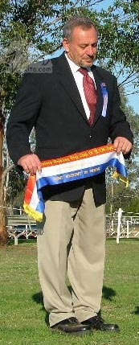
SPAGNOLO, Mr. Guy
New South Wales, AUSTRALIA
ANKC All Breeds
Guy Spagnolo’s lifelong love affair with Labrador Retrievers began when he was just nine years of age. Since that first much-loved Lab his interest in the breed has never waned – exhibiting them from the age of 16 and breeding his first litter in 1974. The rest, as they say, is history – with his Driftway Labradors sweeping all before them. From his first homebred bitch taking out Puppy in Group and then two years later Best in Group at Sydney Royal, the Driftway dogs have accounted for multiple Royal Show honours all around Australia, including Best Exhibit in Brisbane and Runner Up Best in Show at Sydney, on more than one occasion. They have also consistently taken out the top awards at Specialty and regular All Breeds shows, both under specialist judges and all-rounders. From the mid 1970s to the late 1980s Guy has also successfully exhibited English Cocker Spaniels. He has bred more than 80 Champions over the years, exporting his dogs to the United States, Canada, the Philippines, New Zealand, South America and Japan – where many of them have collected overseas show titles and been the top winners, both in their breeds and at All Breeds level.
In 1980 Guy started judging Gundogs and by 1992 had been awarded his All Breeds licence. He has adjudicated at dog shows in Sweden, Finland, Denmark, Italy, the United States, Canada, New Zealand, South Africa, Japan, Argentina, Chile and Uruguay as well as throughout Australia. Guy has also judged junior showmanship on various occasions, including Junior Handler classes at both Sydney and Brisbane Royals.

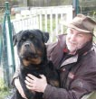
Dirk Vandecasteele
Belgium

I officially judge the IPO-program since 2001 and have then also been appointed as Rottweiler-judge.
Why does one decide to follow this not always easy road ?
For me this is the question for the limit of ones love and fascination for dogsport and the breed. The moment came I realised that my interest for the Rottweiler and for the dogsport, was no longer just a mere hobby or recreative activity.
Practising a free profession, I have little spare time but all there is, is dedicated to my activities as president of the Belgian Rottweilerclub and now also vice-president of the International Federation of Rottweilerfriends, visiting and participating dogshows and –trials, training dogs, writing articles, reading, photographing, etc.. etc.. At the end, I came to realise that even my conversation with my wife knew only one topic: the Rottweiler or the training- and trialfield… ! Limiting or bringing this fascination back to “acceptable” proportions was no option, canalising it to another level, the one of judging the Rottweiler in conformation and judging utility-dogs during working-trials, was. This way, one can experience the breed or the utility dog in general and the sport in a pure and even more fascinating way, not based on a selfish urge to win or to compare other dogs with ones own dogs or own results, but with a knowledge and objective eye for the true beauty of the breed and dogsport.
Since 2001 I’ve had the privilege and pleasure to judge all over the world, including many national and international workingtrials amongst which many Belgian selection-trials for the national and FCI-worldchampionship all breeds, the Belgian national championship all breeds, the national championship of the Italian Rottweilerclub and as an absolute highlight the protection part of the IFR-worldchampionship IPO III in 2005 as a highlight.

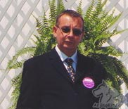
Wolfgang Schnitzer
ANKC Terrier, Gundog, Hound, Working
Australia

I have been involved in showing and breeding dogs for many years. I have judged extensively throughout Australia, New Zealand, Japan, Philippines, Thailand and the United States of America. My involvement has included Standard Long Haired, Standard Smooth Haired Dachshunds, English Springer Spaniels and more recently Pugs.

For many years I have concentrated on the breeding and exhibiting of Standard Long-Haired Dachshunds, in partnership with Eric Soti under the “Keaton” prefix. With this variety we have been successful in breeding Royal Challenge winners in most States of Australia. We have also been successful in the Specialty ring, with Best in Show winners, which were either bred or owned by us. This has included winning Best Exhibit In Show and Runner-up in Show at five of the nine National Specialties held. We have bred the only two Grand Champion Longhaired Dachshunds in New Zealand. We also have a dog in Singapore that is a Grand Champion. We are the only Longhaired Dachshund breeders to have bred a dual Australian and New Zealand Grand Champion.

I am licenced for the Terrier, Gundog, Hound and Working Dog Groups under the Australian National Kennel Control system.

